**Week 4 Ex-6-Output**

**1. Trigger a Known Exception**

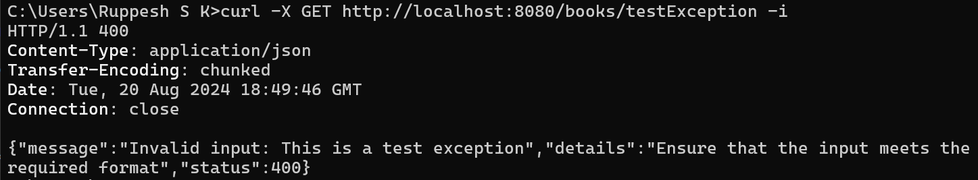

**2. Test an Endpoint with Invalid Input**

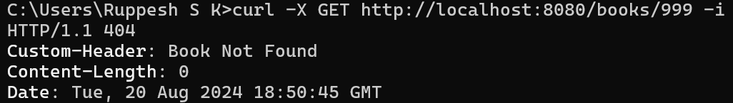

**3.** **Test a Bad Request**

